Assessment in Modern Foreign Language (MFL)

Informing Pupils of Targets:
- On the first page in MFL books, year group skill development overviews are be glued into pupils books and referred to in all units of work over the course of the year.
- Pupils are guided to self-assess and peer-assess (where appropriate) against these targets in each lesson so that they are fully informed about their achievements, progress and next steps
- This ensures that pupils are accurately informed about the skills and knowledge they will be developing within every lesson and over time as part of a wider unit of work

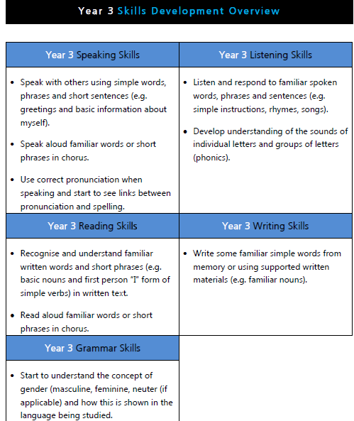

Ongoing Assessment:
- Class Teachers and HLTAs (where appropriate) use a range of Assessment for Learning strategies in order to formatively assess pupils’ achievements and progress within lessons.

Formal Assessment:
- Pupils’ achievements and progress are assessed formally by Class Teachers at the end of each unit of work (once per half term).
- An online Tracking and Progression Tool (provided by Language Angels) is used to minimise unnecessary workload and enable data to be automatically calculated.
- Class Teachers can choose whether to update the online tracking and progression tool at the end of each lesson or at the end of the unit of work
- The Language Angels Tracking & Progression Tool is designed to work by recording the progress of each of your pupils as measured by the Language Angels End Of Unit Skills Assessments provided in Lesson 6 of each teaching unit
- Each pupils learning and assessment is assessed and measured against each of the four key language learning skills (speaking, listening, reading and writing)
- Each of these four skills is assessed by asking the pupils in your class to answer 5 questions per skill - giving a possible maximum score of 20 for any unit skills assessment. The questions are unit specific and are based on the language your pupils have been taught in that particular unit.
- Five performance bands (or level descriptors) are then used to best describe the performance and progression of each pupil at any given time in their language learning journey. The performance bands also have a percentage mark equivalent.
- The performance bands/level descriptors used in the Tracking & Progression Tool are:

0%-25% | Working Towards ARE
26%-45% | Emerging ARE
46%-65% | Working at ARE
66%-85% | Working Towards Greater Depth
86%-100% | Working at Greater Depth

- The Tracking & Progression tool then enables teachers to generate reports showing class progression against the 12 teaching targets stipulated in the DfE Key Stage 2 Languages Programme of Study as well as individual pupil performance in each language learning skill. They will also be able to describe performance using the performance bands detailed above.

Reporting and Tracking:
- Class Teachers share completed assessment spreadsheets with the Subject Leader and Curriculum Lead (DHT) at the end of each unit
- The data submitted is analysed by Leaders in order to identify trends and areas for further development

Moderation:
- Non-Core assessment data is reviewed termly by Subject Leads, the Curriculum Lead and SLT and is subject to internal moderation.
- Class teachers discuss the attainment and progress of pupils in all non-core subjects at termly Pupil Progress meetings with members of SLT.

